12 November 2021

Main contact
Susanne Diehl
Head of Market Communications
Silica
Phone +49 6181 59-13347
susanne.sd.diehl@evonik.com
Alternative contact
Nina Peck
Head of Market Communications
Smart Materials
Phone +49 201 177-2223
Mobile +49 172 701 7672
nina.peck@evonik.com

Evonik Industries AG
Rellinghauser Straße 1-11
45128 Essen
Germany
Phone +49 201 177-01
www.evonik.com

Supervisory Board
Bernd Tönjes, Chairman
Executive Board
Christian Kullmann, Chairman
Dr. Harald Schwager, Deputy Chairman
Thomas Wessel, Ute Wolf

Registered Office is Essen
Register Court Essen Local Court
Commercial Registry B 19474
Evonik receives Energy Efficiency Award 2021 for waste heat project

- Award from German Energy Agency in category “Think Big! Complex Energy Transition Projects”
- Waste heat from AEROSIL® plant heats apartments in Rheinfelden
- Savings of 10,000 tons of CO₂ per year

Rheinfelden/Berlin. The German Energy Agency (dena) has presented Evonik and the southern Baden energy supplier Energiedienst with the “Energy Efficiency Award 2021” for their joint waste heat project at Evonik’s Rheinfelden production site. The jury recognized the project’s lighthouse character in using industrial waste heat to heat living space and generate electricity.

“We as the jury were particularly impressed by this project’s holistic approach. A lot of players pulled together here,” explained dena as the reason for honoring Evonik and Energiedienst in the category “Think Big! Complex Energy Transition Projects.” For Evonik’s production site in Rheinfelden as well as for its waste heat-emitting AEROSIL® plant, the award is an important sign that they are on the right track when it comes to sustainability. “We approach sustainability holistically,” says Dr. Claudine Mollenkopf, head of the Silica business line. “Utilizing all the waste heat from our production processes is not only good for the environment, it’s also good for our customers and our company. Our customers already frequently obtain a sustainability advantage with our products, and optimizing the use of heat is another important milestone on the way to reducing our carbon footprint.”

The cooperation between Evonik and Energiedienst is based on the 95 °C water produced during the manufacture of silica in Evonik’s AEROSIL® plant. Pyrogenic silicas are used in industrial applications such as silicones, coatings, adhesives, and sealants. In 2021 alone, Evonik’s waste heat has been used to provide climate-neutral heating and hot water for up to 10,000 homes in the surrounding area via pipe bridges and underground pipelines. Evonik had already been using some of the process heat internally: for example, to heat preliminary production stages or buildings on-site. Yet the remaining waste heat had previously remained unused. By releasing heat output of 5 megawatts, up to 10,000 metric tons of CO₂ can now be saved each year.

“Evonik has set itself the goal of reducing CO₂ emissions by 50 percent by 2025. As a production site, we are making an important contribution,” explains site manager Dr. Olaf Breuer. To attain this goal, a number of ideas and measures for greater sustainability have been developed at the site. “The waste heat project is certainly an outstanding example of our commitment. We are very pleased to have now also received an award from dena for it.”

Image download
Press release download
Please visit our website for further information

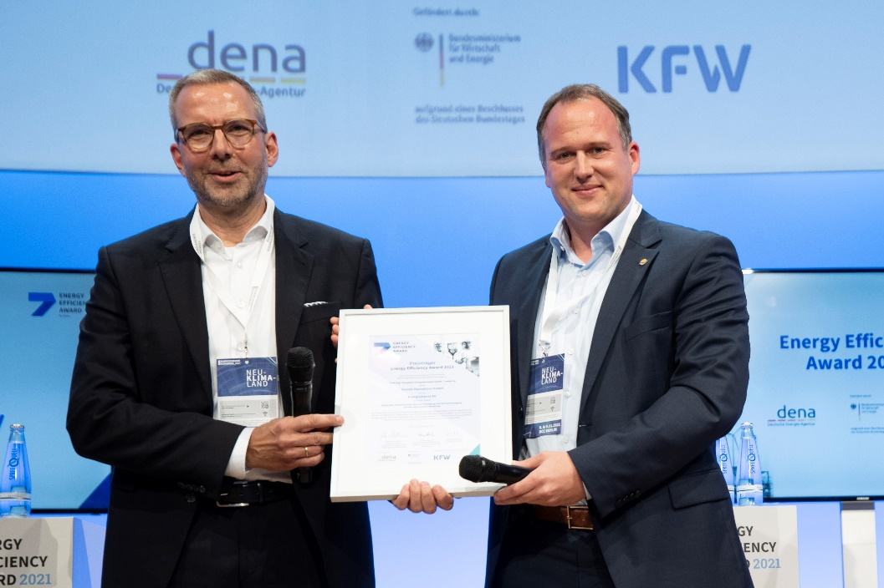

Accepting the "Energy Efficiency Award 2021" in the "Think Big!" category: (from left) Dr. Olaf Breuer, site manager of Evonik in Rheinfelden, Dr. Jörg Reichert, managing director of Energiedienst Holding AG.

Photo: German Energy Agency

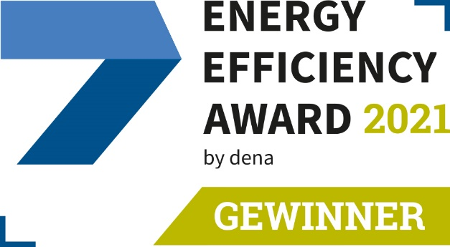

Evonik and Energiedienst: Winners of the Energy Efficiency Award 2021

Photo: German Energy Agency

Company information
Evonik is one of the world leaders in specialty chemicals. The company is active in more than 100 countries around the world and generated sales of €12.2 billion and an operating profit (adjusted EBITDA) of €1.91 billion in 2020. Evonik goes far beyond chemistry to create innovative, profitable and sustainable solutions for customers. About 33,000 employees work together for a common purpose: We want to improve life today and tomorrow.

About Smart Materials
The Smart Materials division includes businesses with innovative materials that enable resource-saving solutions and replace conventional materials. They are the smart answer to the major challenges of our time: environment, energy efficiency, urbanization, mobility and health. The Smart Materials division generated sales of €3.24 billion in 2020 with about 7,900 employees.

Disclaimer
In so far as forecasts or expectations are expressed in this press release or where our statements concern the future, these forecasts, expectations or statements may involve known or unknown risks and uncertainties. Actual results or developments may vary, depending on changes in the operating environment. Neither Evonik Industries AG nor its group companies assume an obligation to update the forecasts, expectations or statements contained in this release.

